Mark Kardash

13 September 2023

SDEV350 6380

Professor Carl Eyler

Test Plan:

Objective:

The goal of this test plan is to effectively test the code for SDEV350 Lab 3, ensuring that all appropriate privileges were given, all profiles, roles, and users have been created correctly, and the Lab generally works as intended.

Step 1:

Before we do anything else, we must first test the connection to the database where the project is being created. In my case, I will be connecting to the database SDEV350MarkKardash.

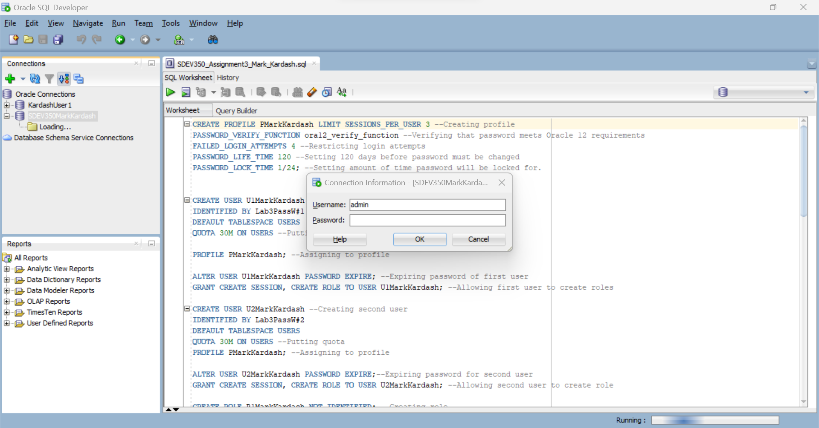

**Figure 1:** Prompted for password.

As can be seen in Figure 1, upon attempting connection to SDEV350MarkKardash, we are prompted for a password.

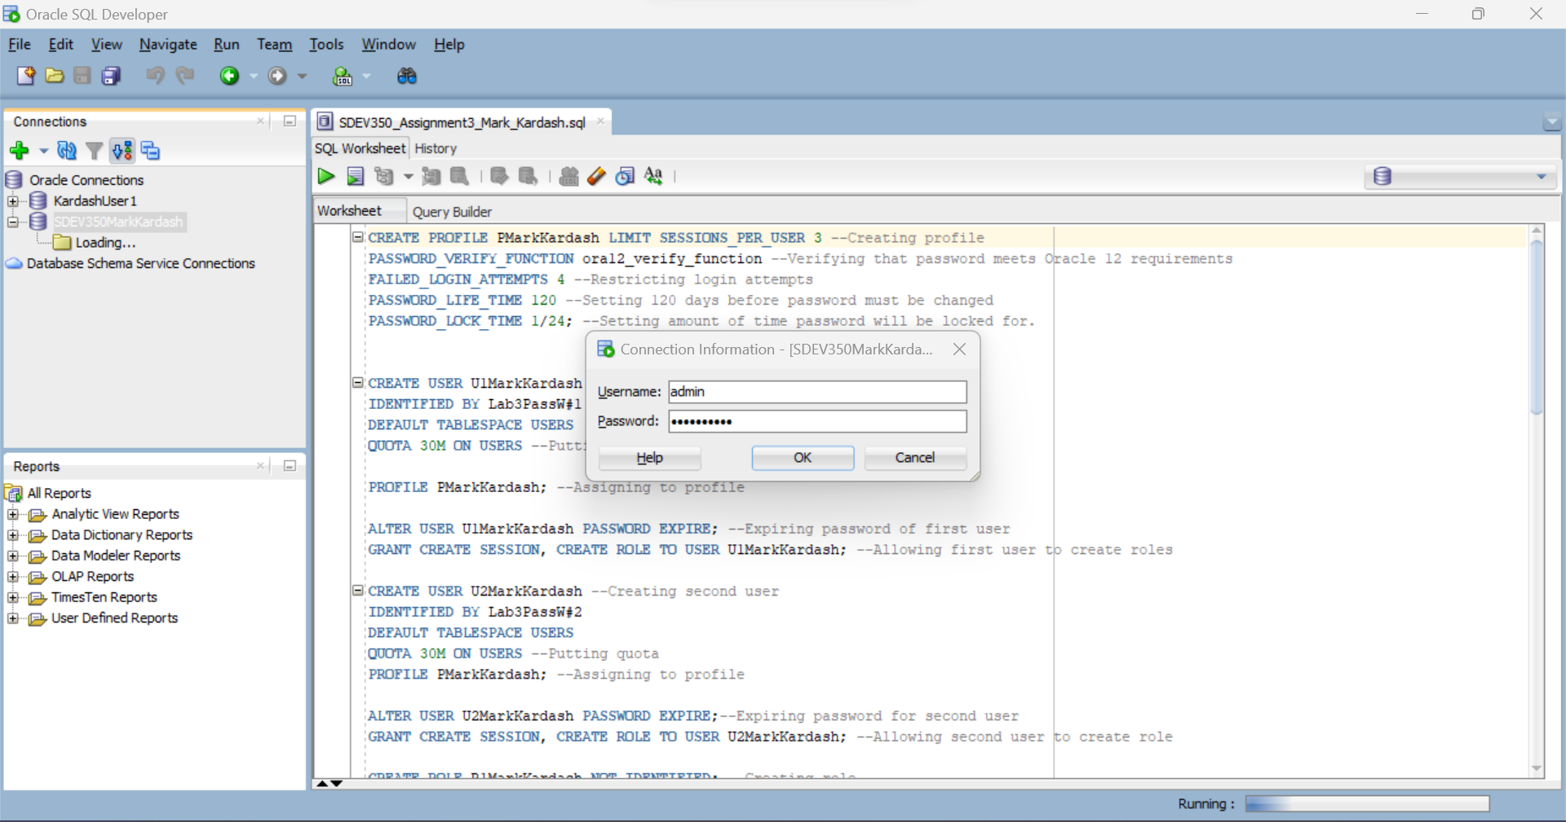

**Figure 2:** Entering the Password

In Figure 2, we enter the password, and click on “OK”.



**Figure 3:** Connected Successfully

Figure 3 shows that we have successfully connected to SDEV350MarkKardash, and have the file for Lab 3 open next to it.

Step 2:

The next step is for us to verify that the Profile, Role, Users, and Tables required from us have been created. To do this, we will use several “SELECT” commands.



**Figure 4**: Displaying all created elements

In the figure above, we put in the statements to display all elements of the code we have created.

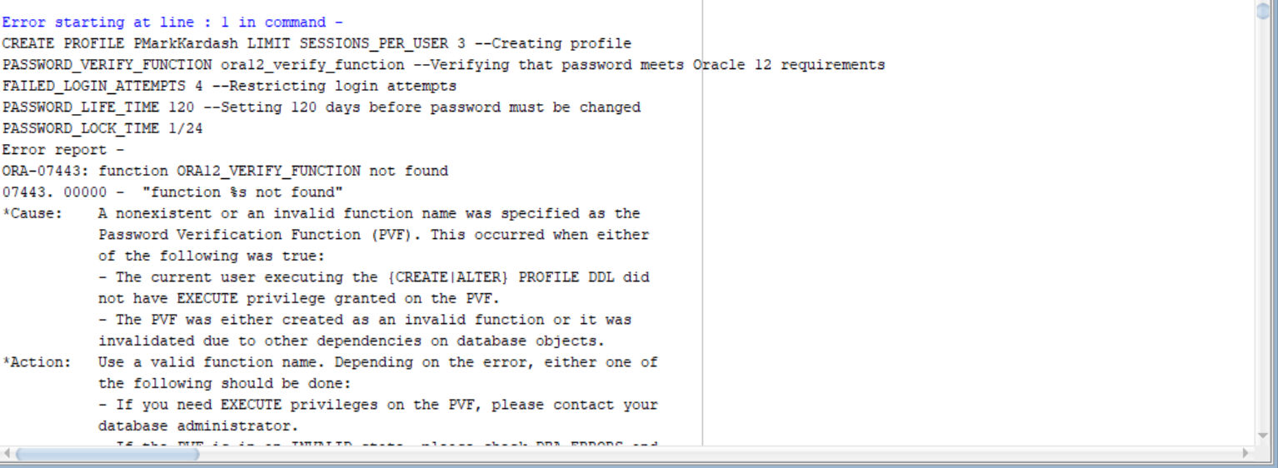

**Figure 5:** Function not found

Above we encounter our first error in this test. It occurred because, while trying to verify the password requirements for Oracle 12, I used an incorrect function, which derailed the rest of the process. As a result, we will correct the mistake and try again.

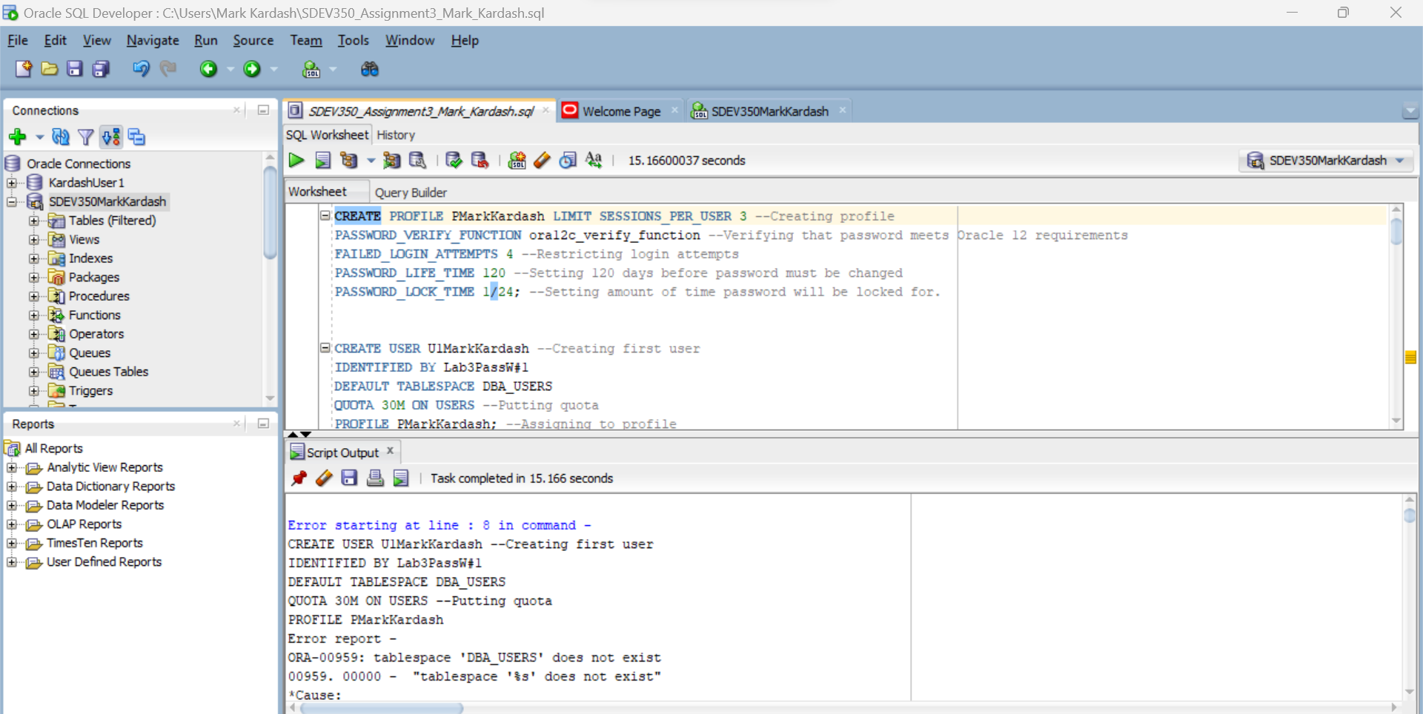

**Figure 6:** Tablespace does not exist.

I was thinking that it would be correct to add “DBA” in front of every tablespace, but remembered that “DBA” is just an example for all databases, as I understood from our materials. This gave me a “Tablespace does not exist” error. So I will remove “DBA” from all tablespace names and try again.

This time, it went better, as some objects were actually created. However, I still had several problems.

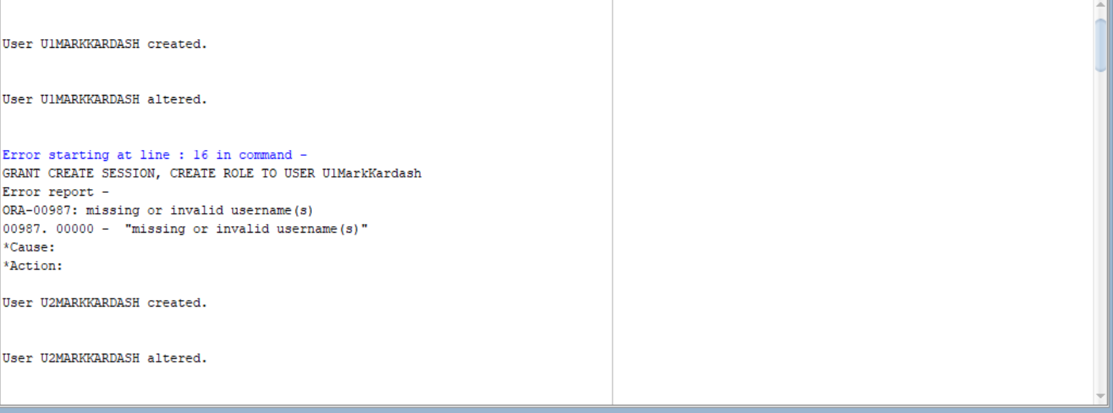

**Figure 7:** Missing or Invalid Username

The first of the errors I encountered was a “Missing or Invalid Username” error. I believe it may be because I specified the word “User” in the query, which I should not have done.

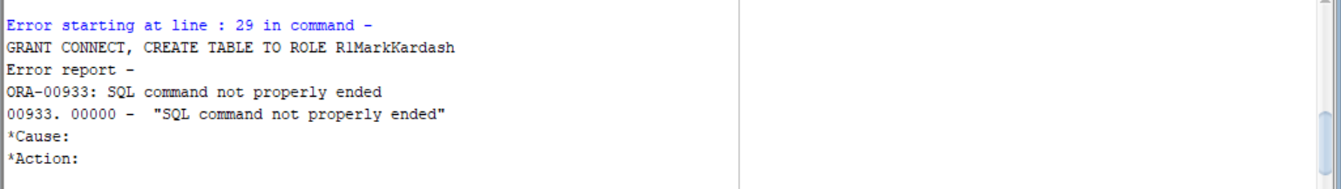

**Figure 8:** Command Not Properly Ended

The error above must have occurred due to me specifying the word “Role” in the query.

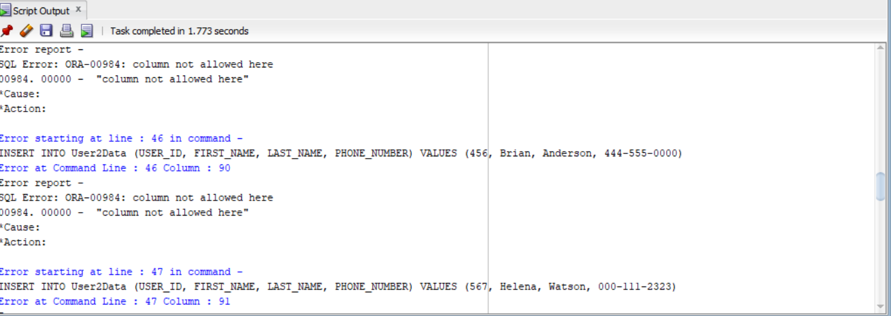

**Figure 9:** Column Not Allowed Here

Then came a series of bizarre “Column Not Allowed Here” errors, the cause of which I shall figure out soon.

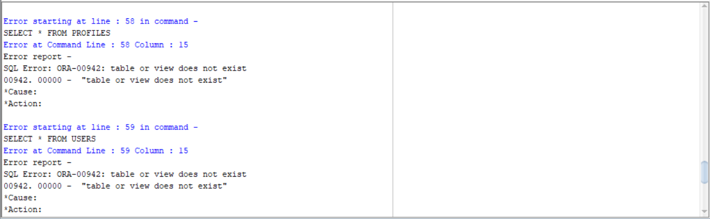

**Figure 10**: “Table or View Does Not Exist”

Finally, each of my queries for the objects returned a “Table or view does not exist” error, meaning that I have incorrectly specified the databases.

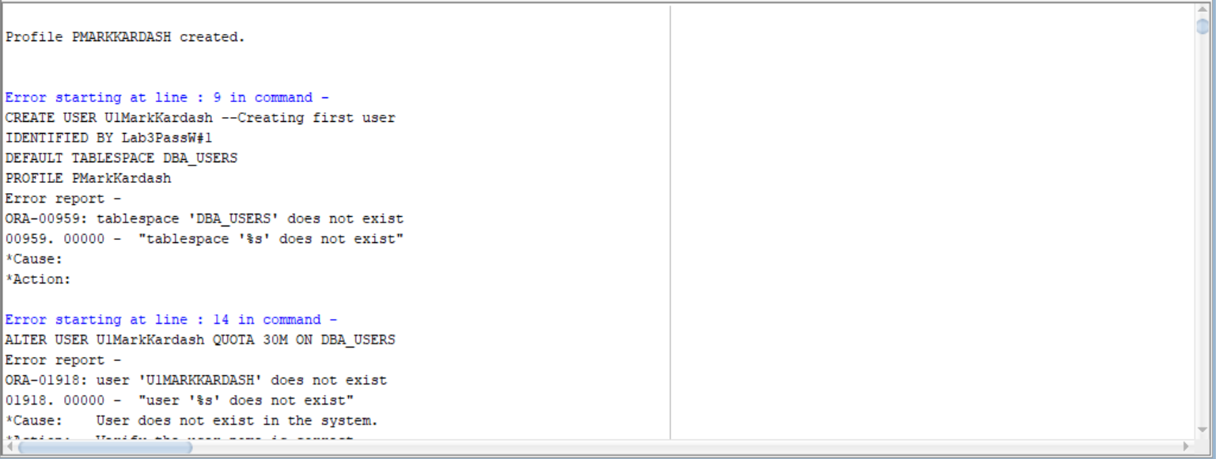

**Figure 11:** Tablespace Does Not Exist

This time, I was only faced with “Tablespace does not exist” and “Column not allowed here” errors. I must have mistakeably identified the tablespace incorrectly, or not given a privilege needed.

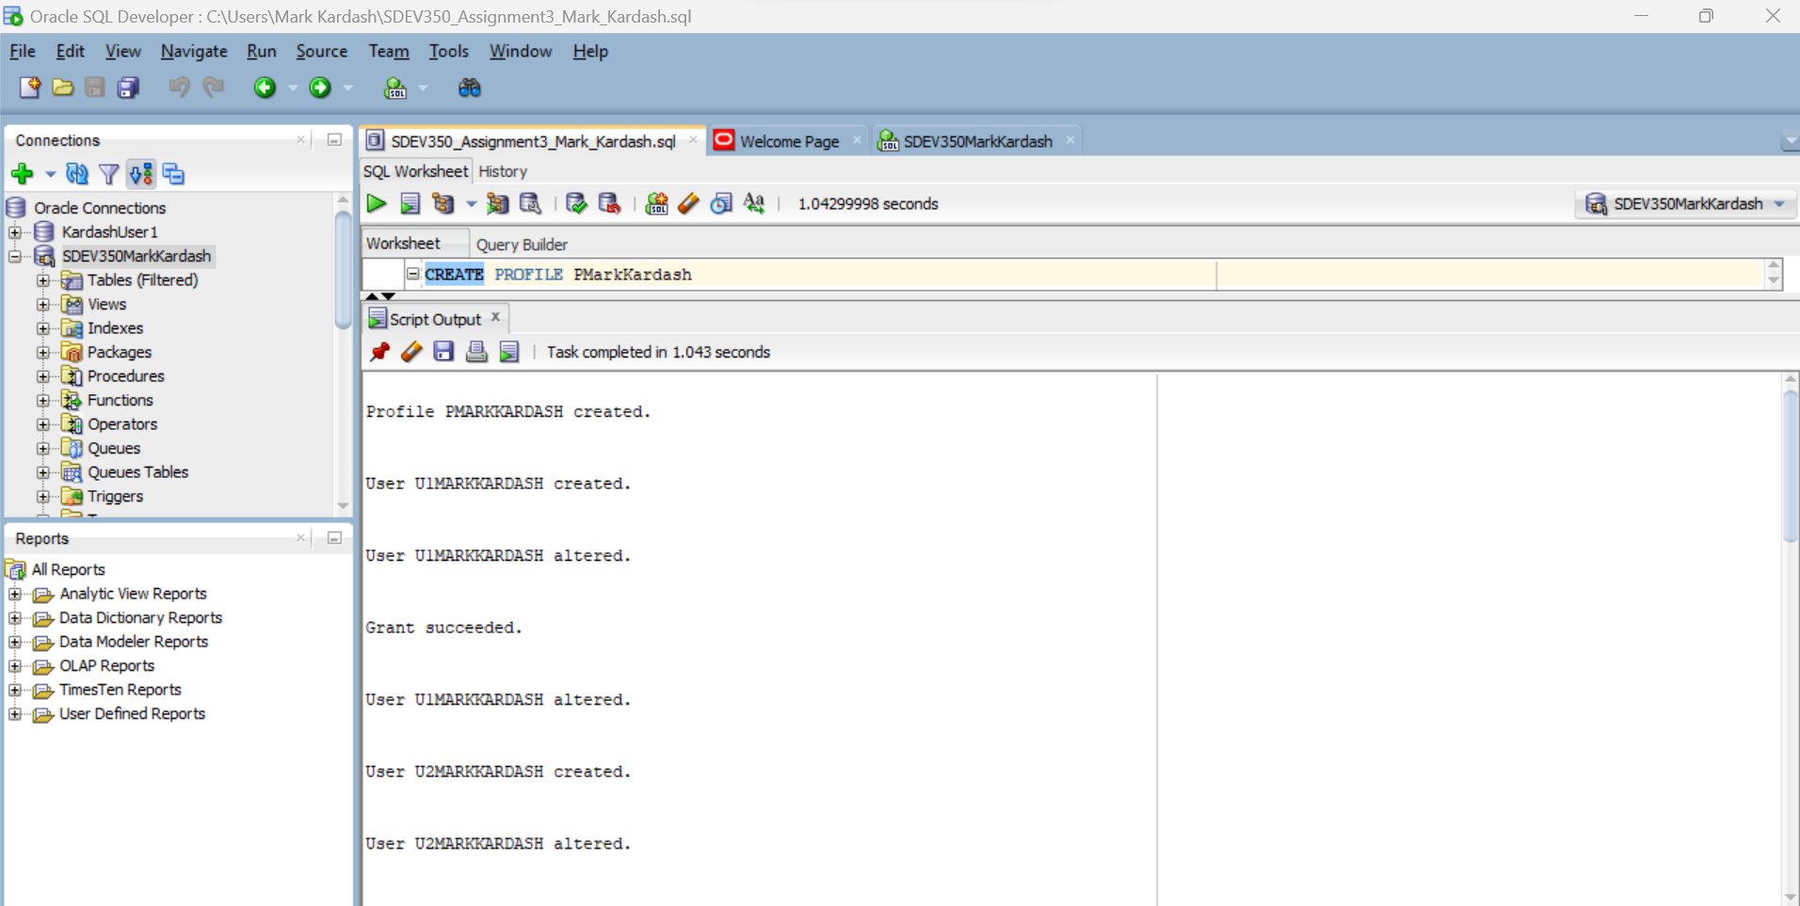

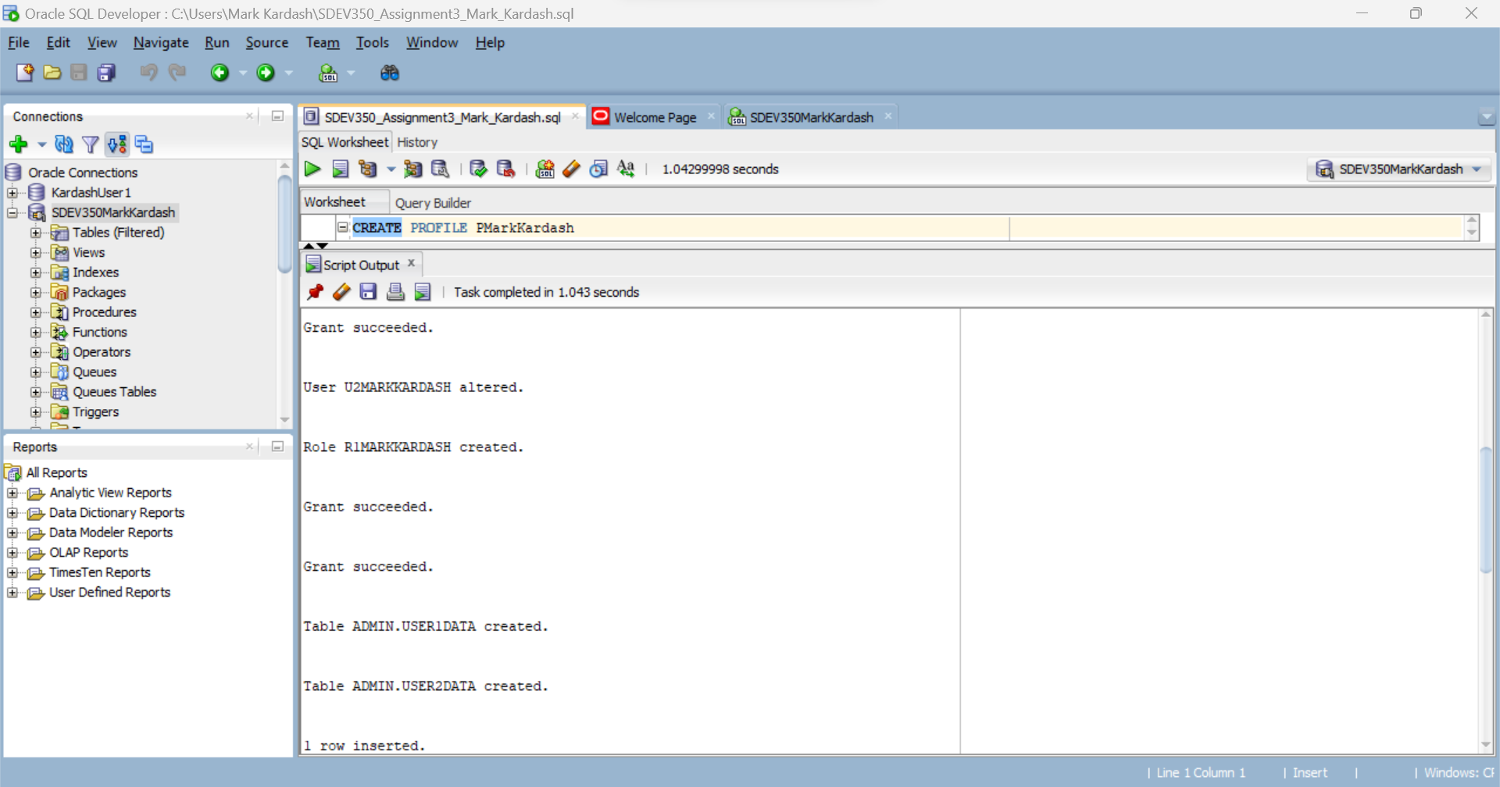

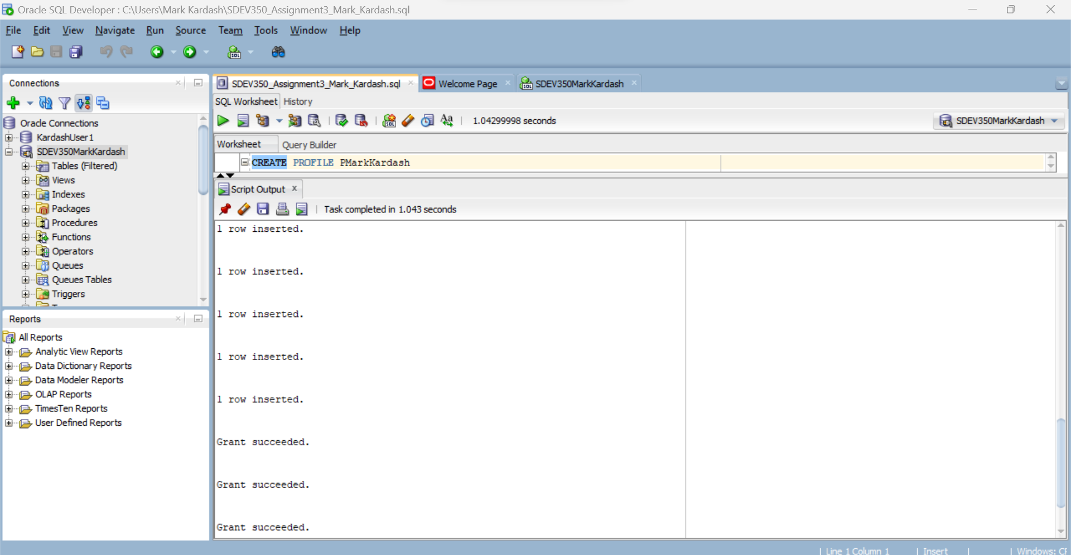



**Figures 12-15:** Successfully running the script.

After a lot of struggle, and modifications including indicating the database as “USERS” rather than “DBA_USERS”, and putting all VARCHAR values of the tables into quotes (ex. “Victor” as opposed to Victor), I was able to run the entire script successfully, creating all objects and executing all commands. As proof, I used the the SELECT FROM commands below to display all results.

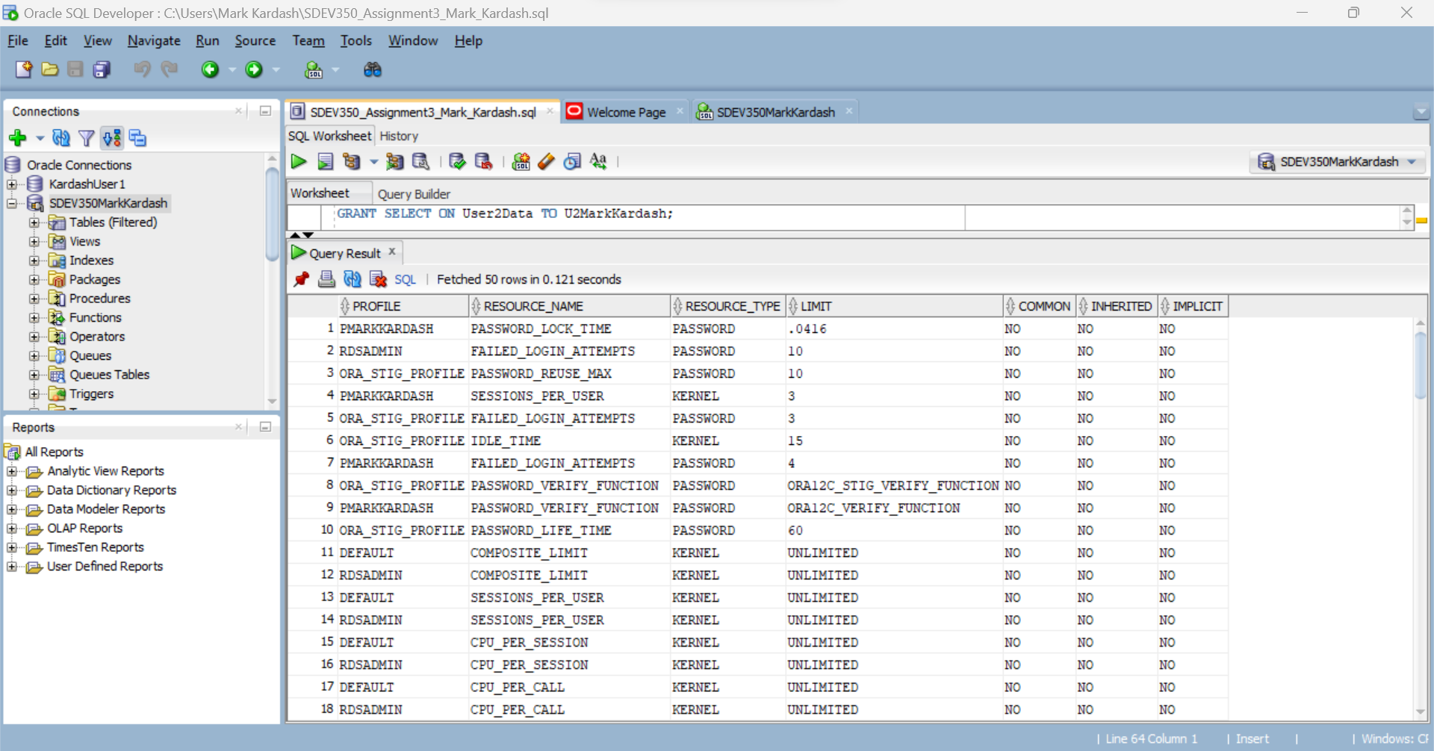

**Figure 16:** SELECT * FROM DBA_PROFILES results.

In the figure above, we queried all profiles from the database, verifying that our PMarkKardash profile has, indeed, been created. I am guessing that the reason for there being multiple iterations of the profile is that, in my effort to correct my mistakes, I dropped and re-created the profile multiple times.

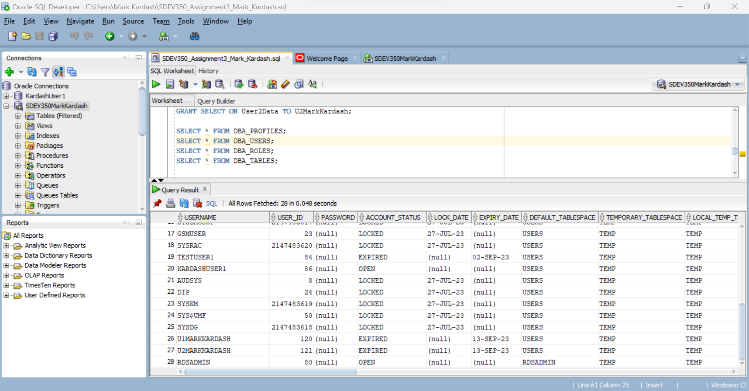

**Figure 17:** SELECT * FROM DBA_USERS results.

By querrying all users from the database, we confirm that our users U1MarkKardash and U2MarkKardash have been created.

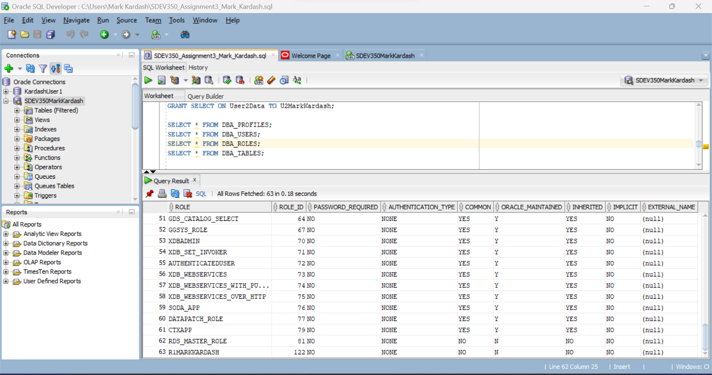

**Figure 18:** SELECT * FROM DBA_ROLES results.

Selecting all roles in the database, we can see that our “R1MarkKardash” role has been created.

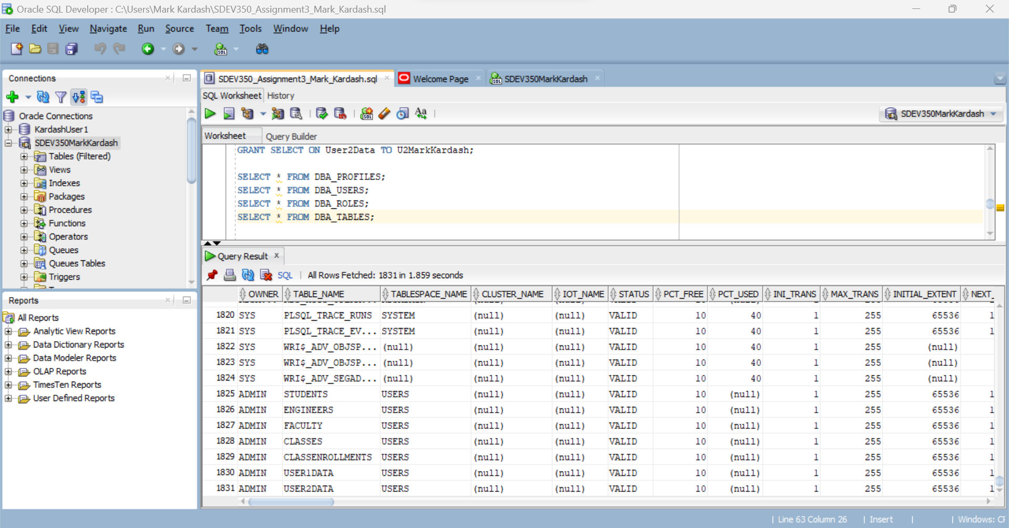

**Figure 19:** SELECT * FROM DBA_TABLES results.

In the same way as the previous three times, we confirm that we have created our tables.

Step 2:

Now that everything has been created, we will try connecting and loging in as each user separately. Let’s start with U1MarkKardash.

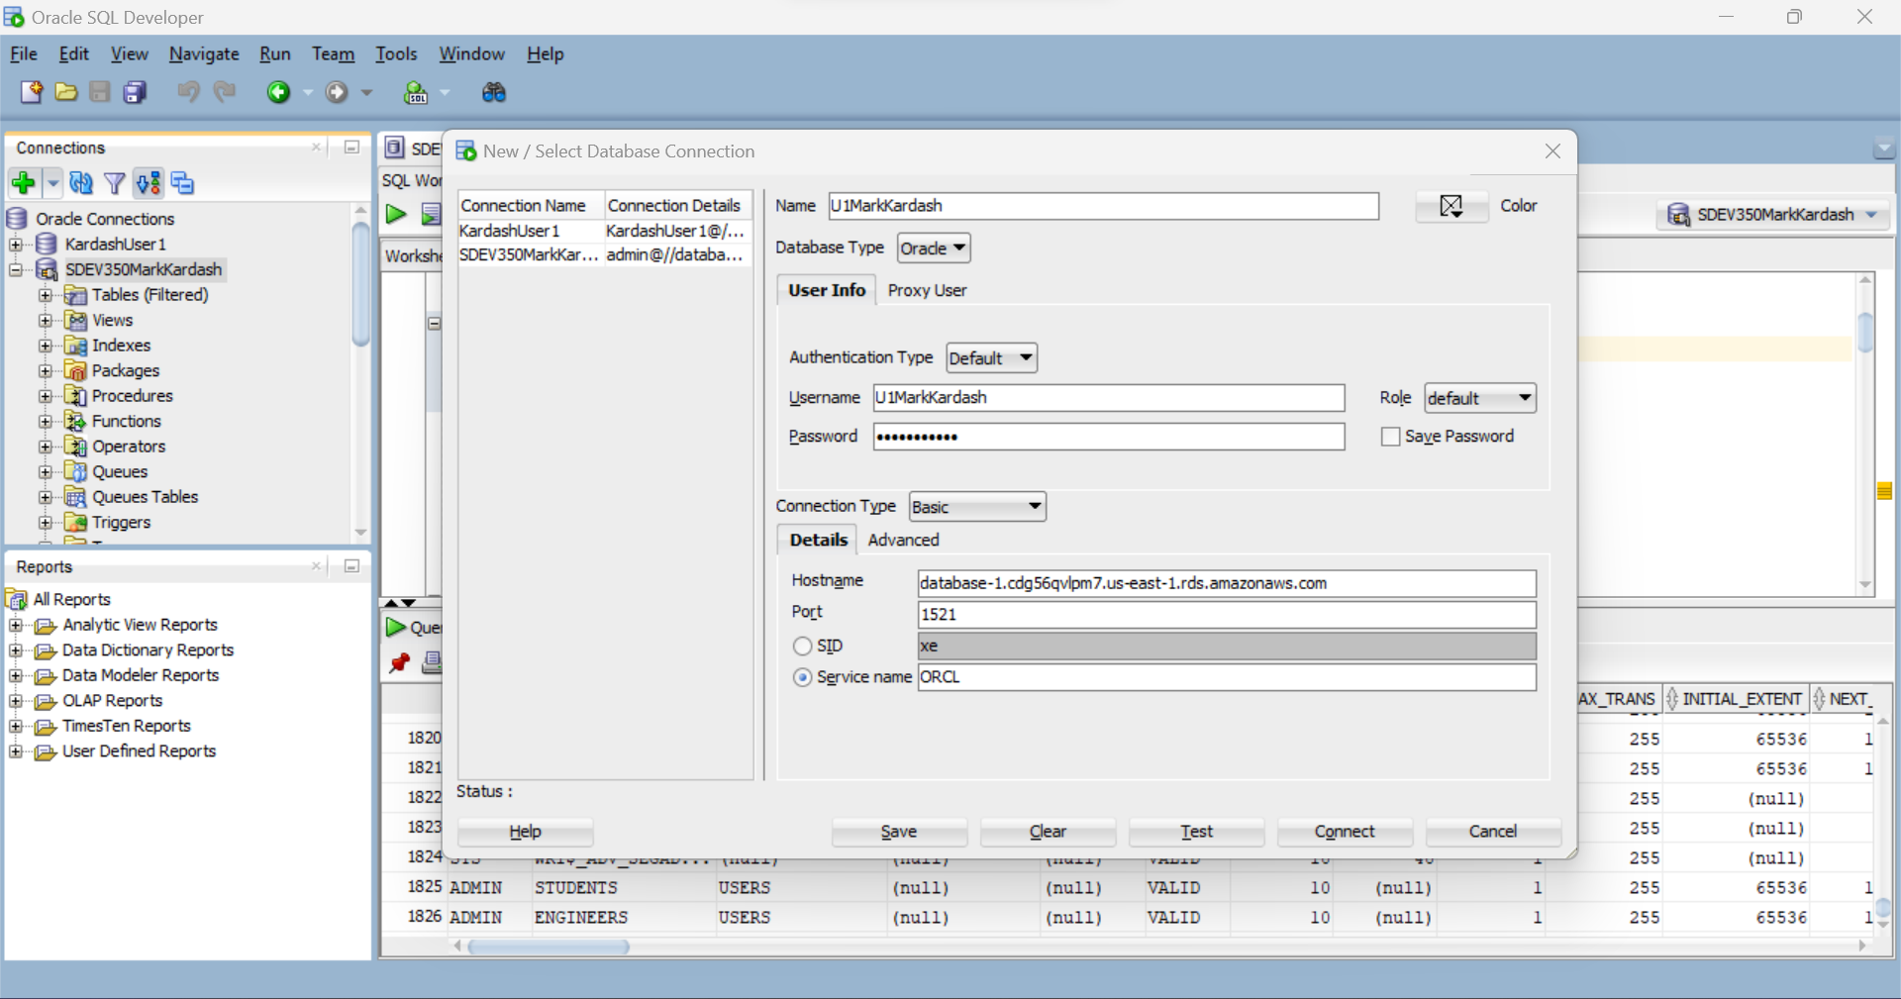

**Figure 20:** Entering Credentials and Hostname for first user.

First, we enter all the appropriate information to make a connection to U1MarkKardash.

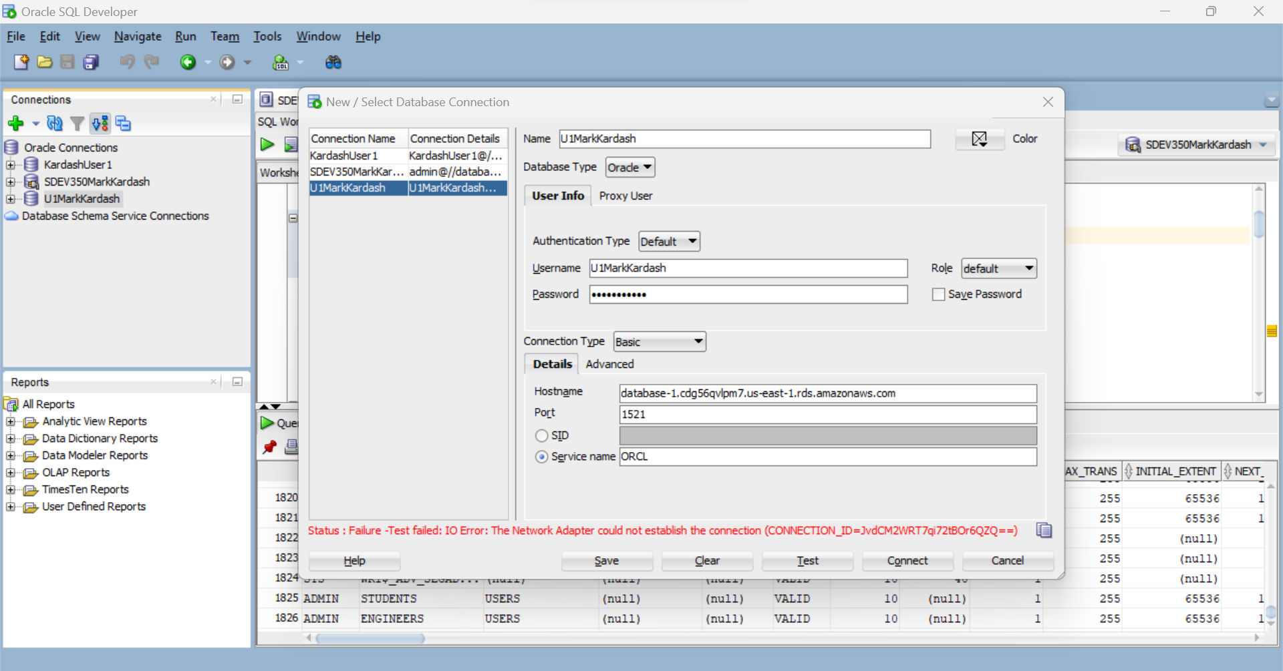

**Figure 21:** Could Not Establish Connection.

As seen above, the database informed us that connection could not be established. Perhaps this means that we have not entered a password meeting Oracle 12 requirements.

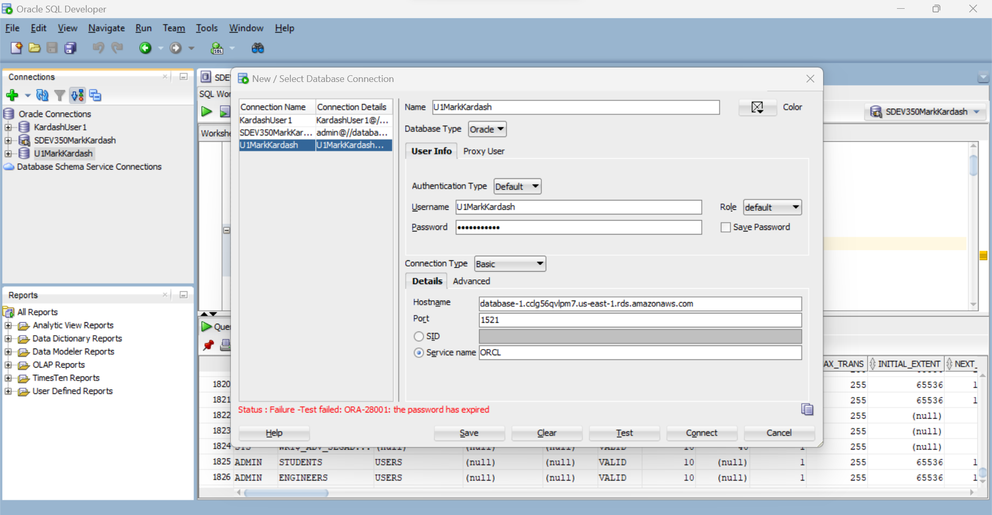

**Figure 22:** Expired Password

As it turned out, we simply had gotten the hostname wrong, and, upon correcting it, we got the expected “Password has expired” error.

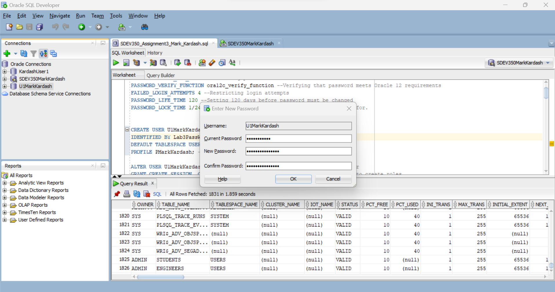

**Figure 23:** Changing the password.

After saving the connection, we change the password from “Lab3PassW#1” to “NewLab3PassW#11”.

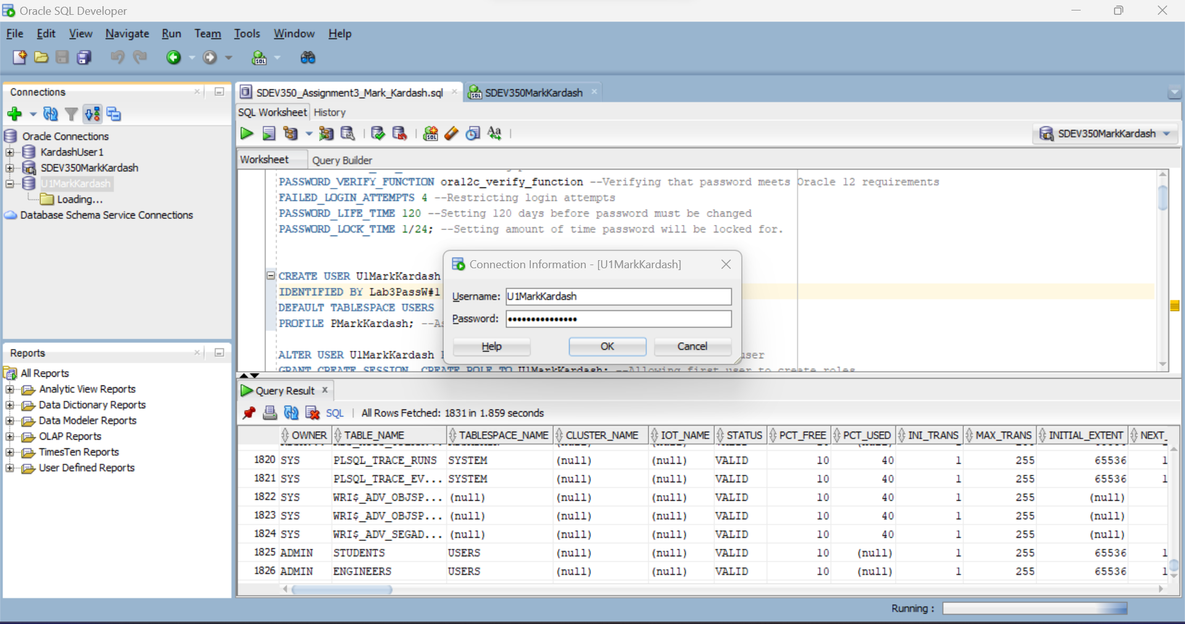

**Figure 24:** Logging in with the new password

Now that we have changed the password, we login with the new one.

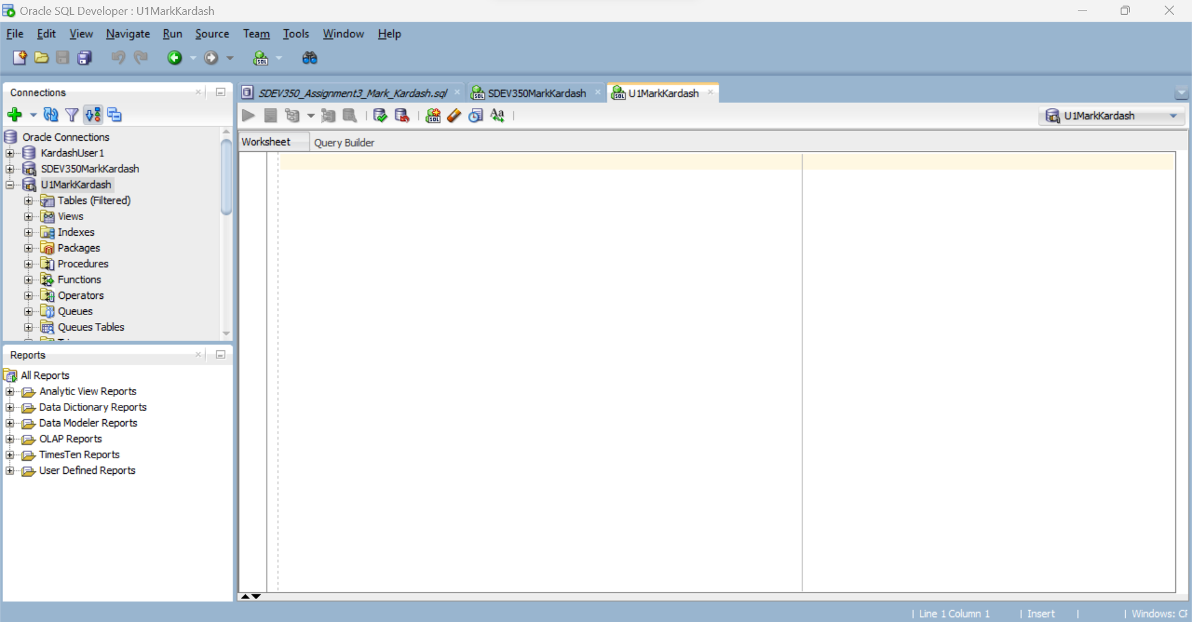

**Figure 25:** Successful connection to U1MarkKardash.

After much struggle, we have finally connected to U1MarkKardash successfully.

Step 3:

It is now time to test all of the privileges given to U1MarkKardash, as well as those not given to it. As we saw from our success in establishing a connection, the role “CONNECT” granted to the database earlier already works. Evidently, so does the “CREATE SESSION” privilege.

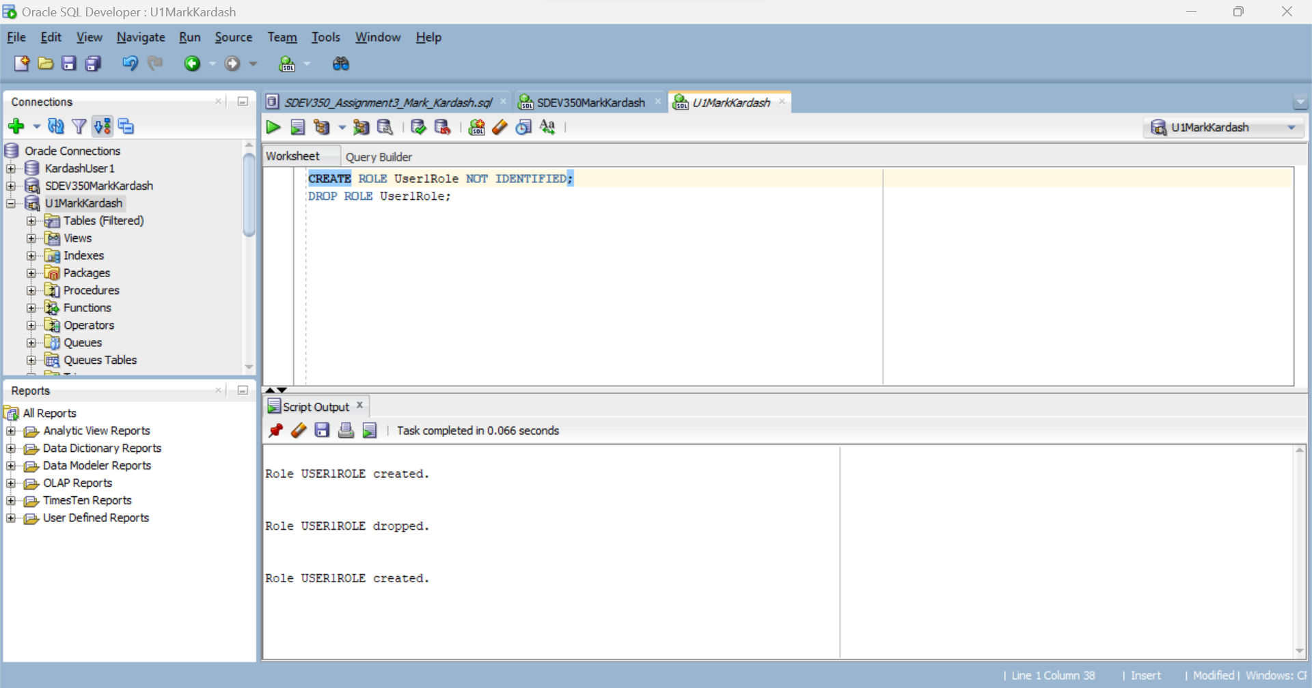

**Figure 26:** Creating Role in U1MarkKardash.

The first privilege I tested for U1MarkKardash was CREATE ROLE. I even dropped it and recreated it just to see if it works. As we see from the figure above, all of these things were successfully performed.

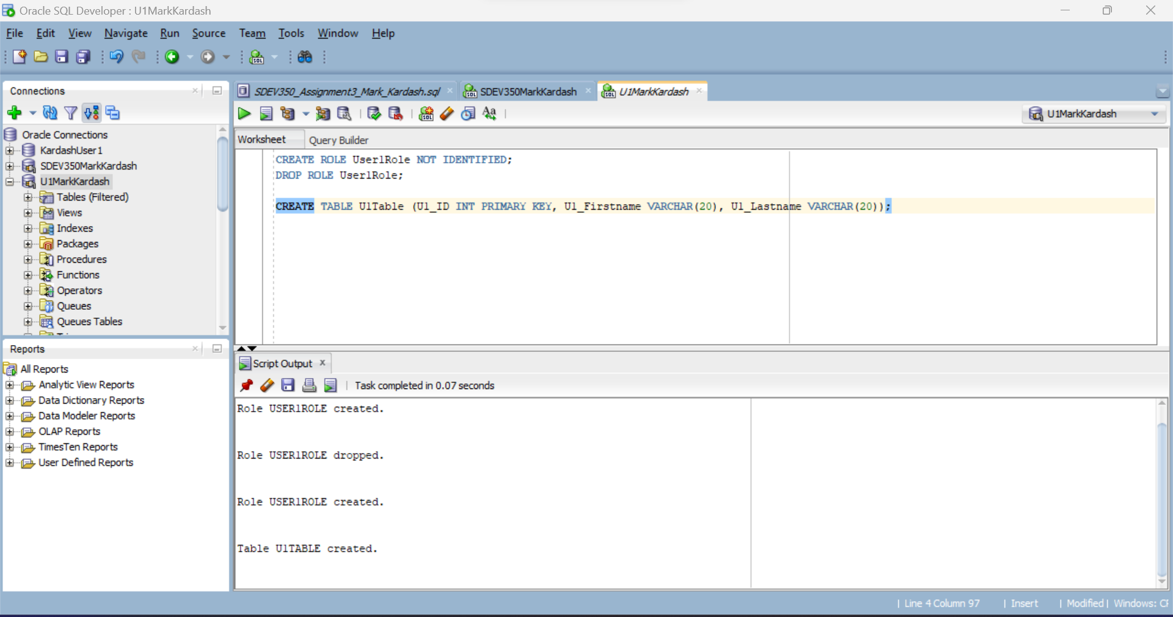

**Figure 27:** Creating Table in U1MarkKardash

To test the CREATE TABLE privilege of U1MarkKardash, I created U1Table, with three columns: U1_ID, U1_Firstname, and U1_Lastname, the ID being the primary key. The user passed this test with flying colors.

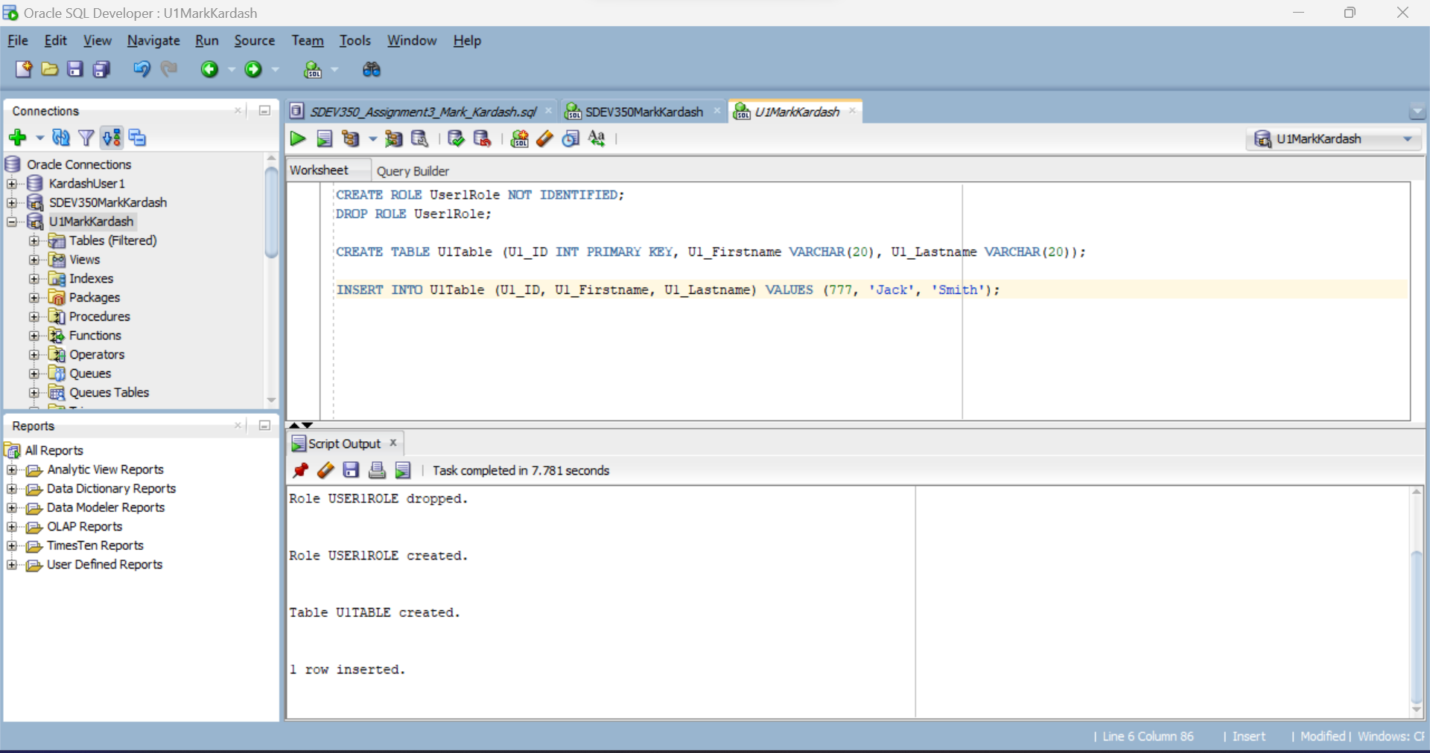

**Figure 28:** Inserting row into U1Table.

As an additional test, I inserted a row of values into U1Table. This was also done successfully.

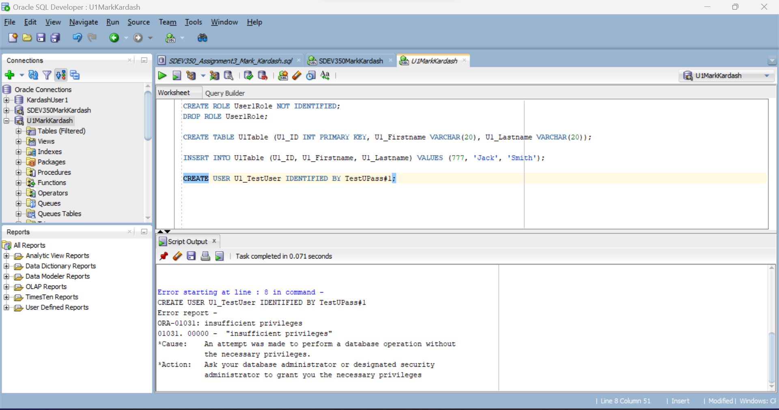

**Figure 29:** Example of Insufficient Privileges for U1MarkKardash

To verify that U1MarkKardash has not been granted any unwanted privileges, I decided to create an example USER within the user. Per the image above, we are given an “Insufficient Privileges” error, therefore passing the test successfully.

The final two privileges that we are going to test for this user are the SELECT and INSERT statements as applied to User1Data.

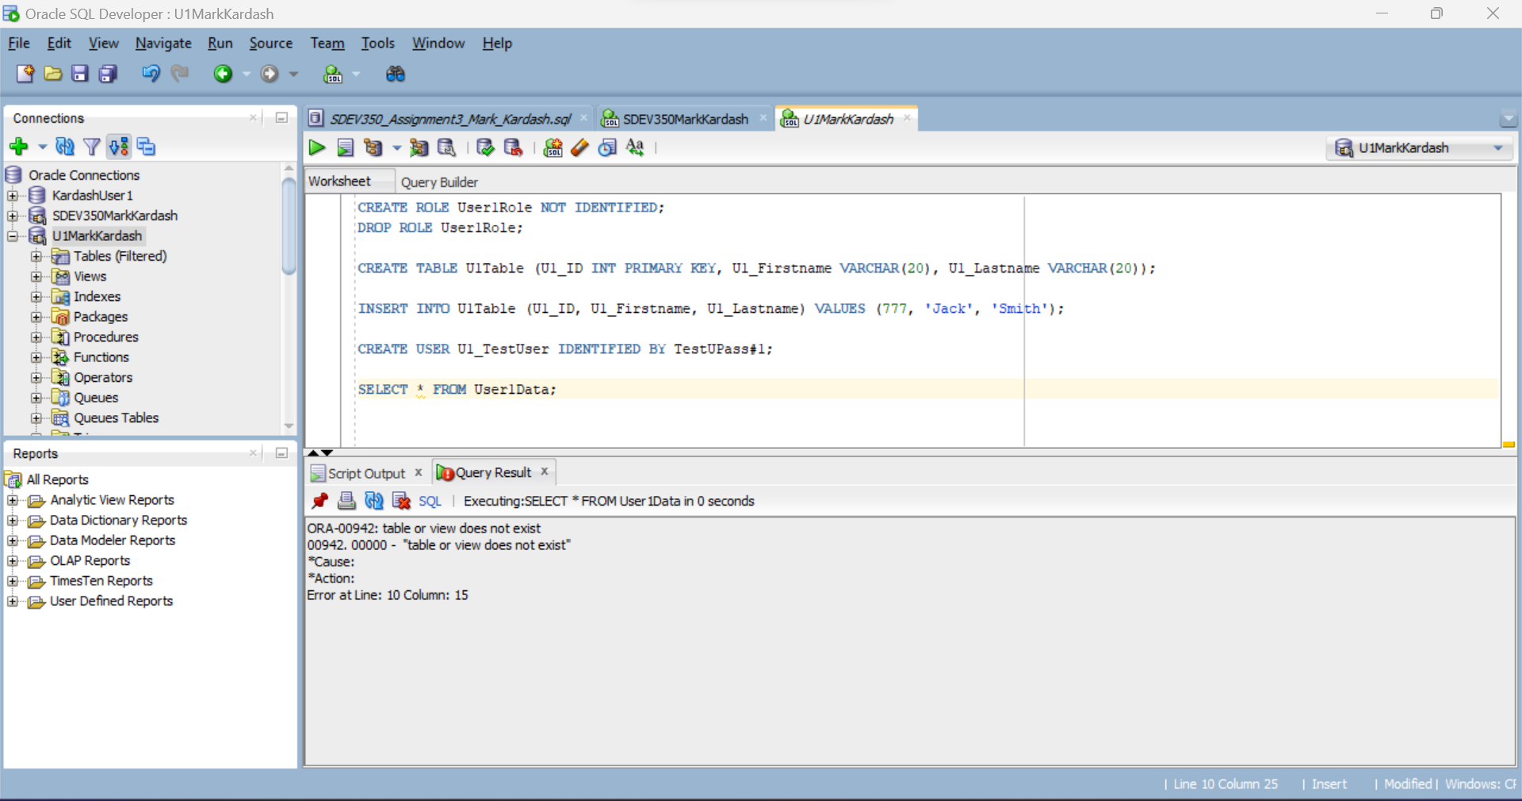

**Figure 30:** “Table or view does not exist” while attempting to SELECT from User1Data.

Upon attempting to select all data from the table User1Data via U1MarkKardash, we are met with a “Table or view does not exist” error. Our GRANT and SELECT statements need to once again be examined.

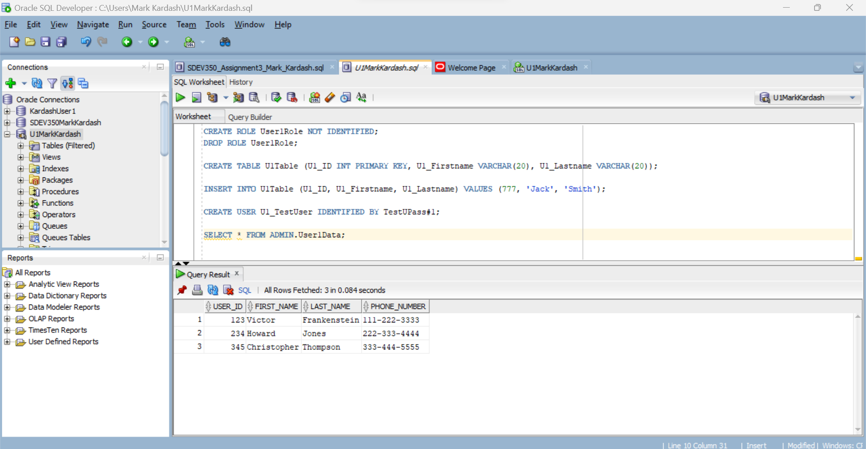

**Figure 31:** Selecting All from User1Data

After changing the “Select” query from “SELECT * FROM User1Data” to “SELECT * FROM ADMIN.User1Data”, we were able to display all records from the User1Data table. This means that the word “ADMIN” needs to be added to our next queries as well.

Next, we will test the “INSERT” query to “User1Data”.

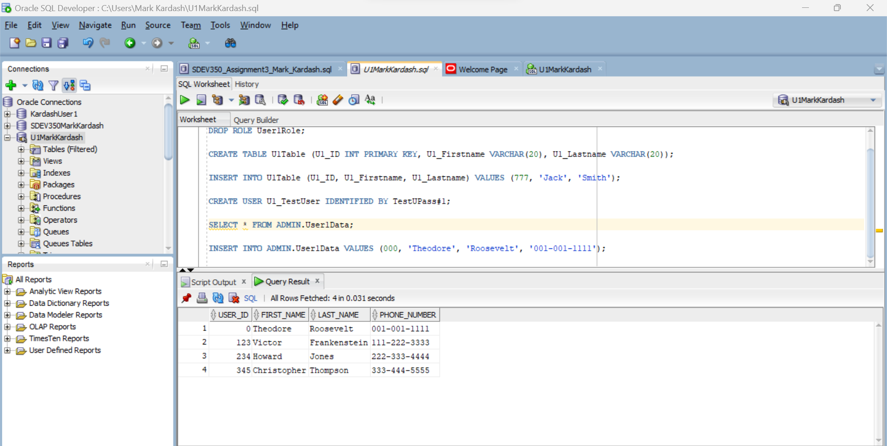

**Figure 32:** Inserting record into User1Data.

As a final test for this user, we inserted a third row into the User1Data table, and re-displayed the results, to show it has been inserted successfully.

Step 4:

The final step in this test plan will be to repeat all tests performed in Step 2 for the second user, U2MarkKardash.

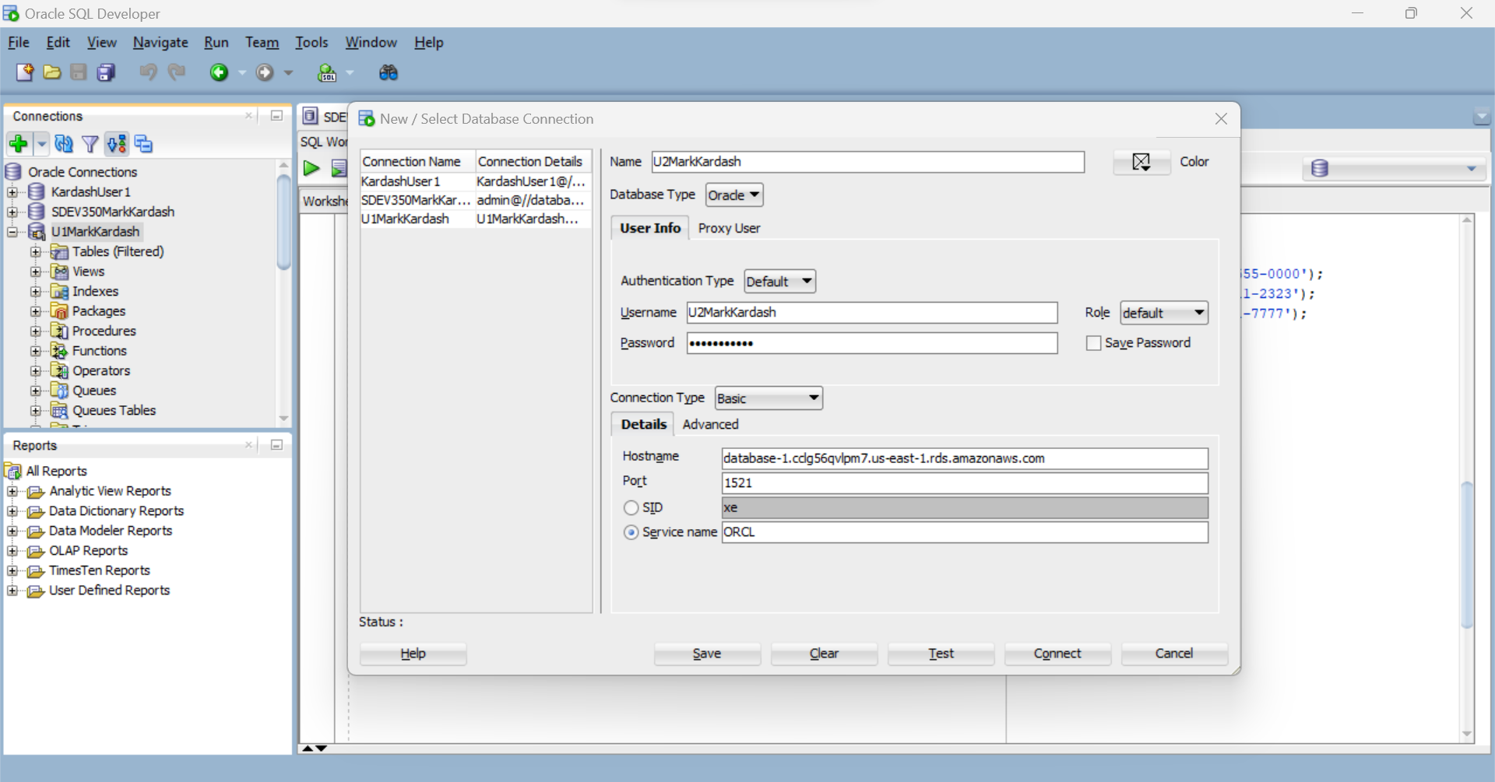

**Figure 33:** Entering credentials for connection to U2MarkKardash

In the above figure, we enter all credentials to connect to U2MarkKardash. Having learned from our previous difficulties, we check that we enter the correct hostname.

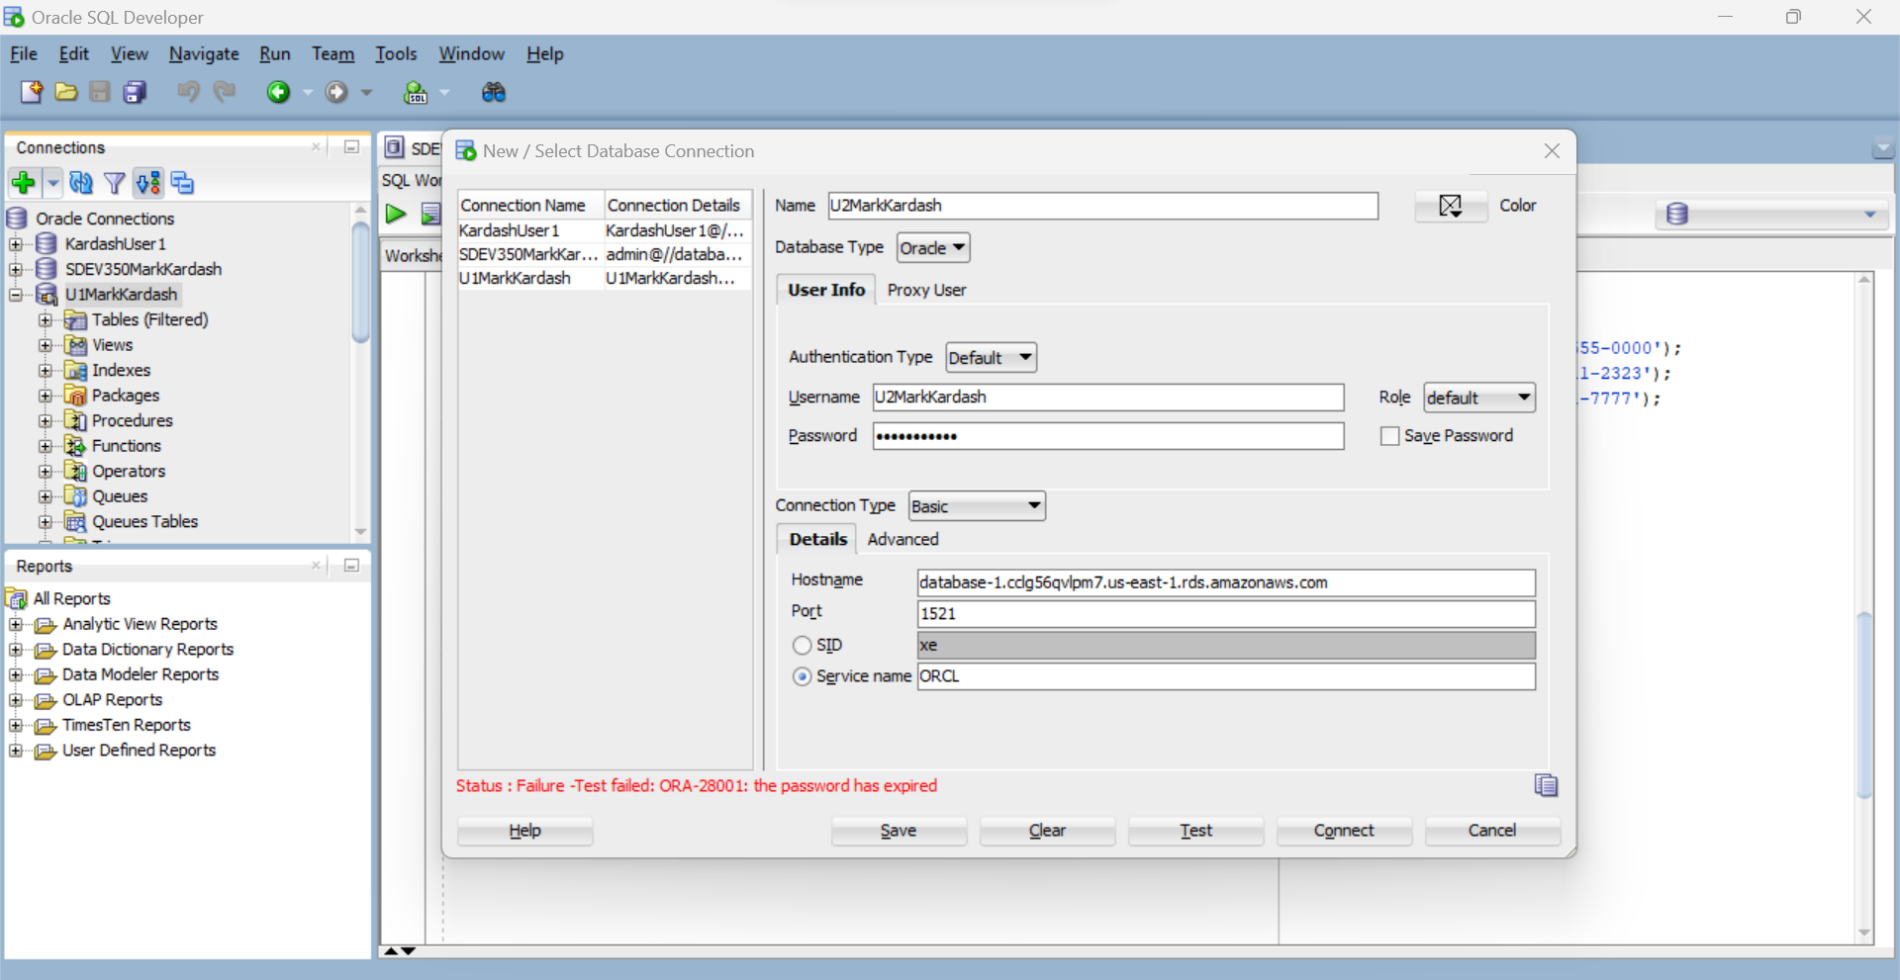

**Figure 34:** Password expired for U2MarkKardash

As expected, above we are shown a “Password has expired” error again. We will therefore save the connection and attempt to change the password.

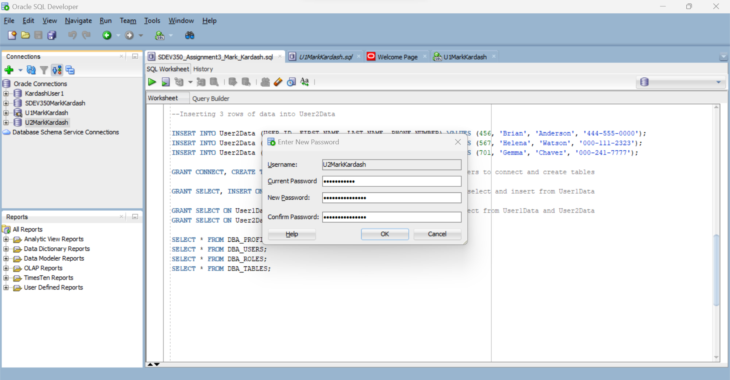

**Figure 35:** Resetting the password for U2MarkKardash

In order to connect to the second user, we update their password from the expired “Lab3PassW#2” to the new “NewLab3PassW#22”.

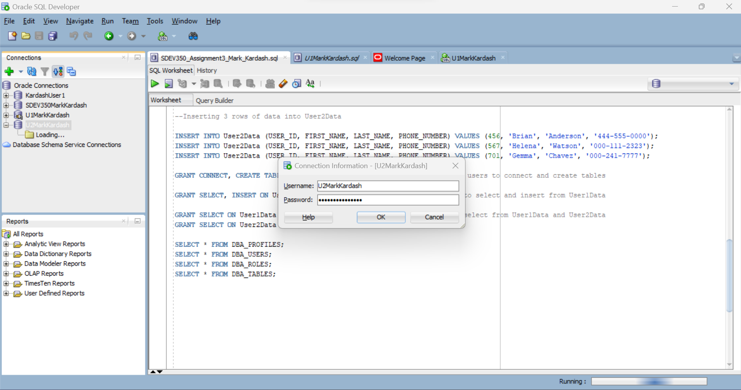

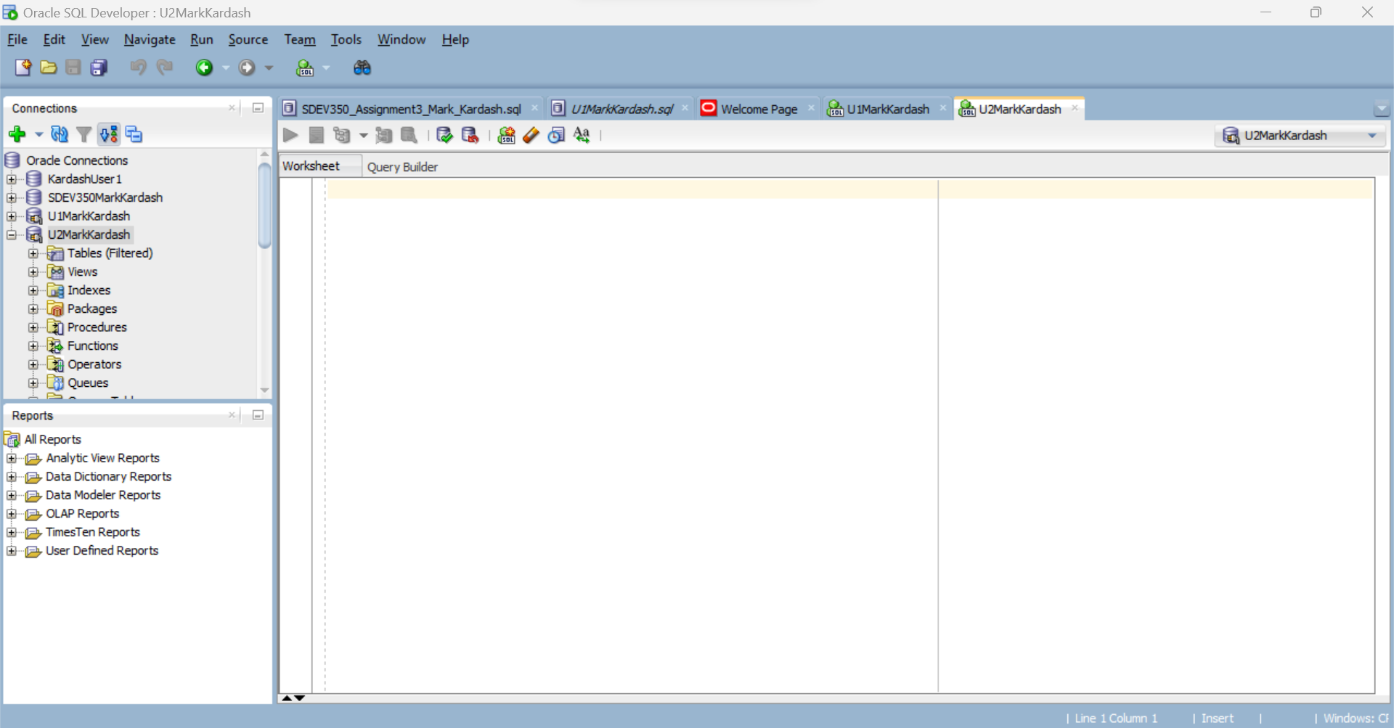

**Figure 36-37:** Logging in to U2MarkKardash

As indicated in the figure title, we now login to the second user with the new password. Our attempt is a success.

Step 5:

This final step will repeat all actions from Step 3 for U2MarkKardash.

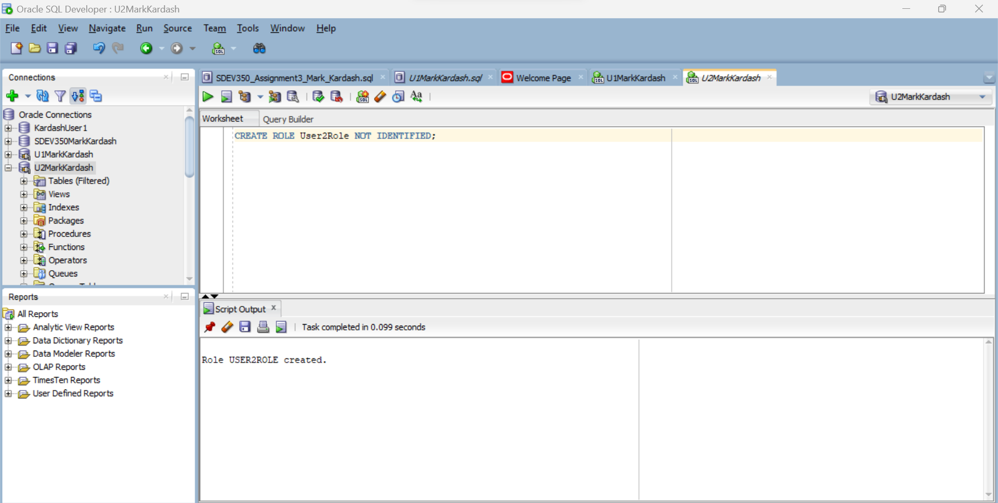

**Figure 38:** Creating role for U2MarkKardash

As with the previous user, we are once again very successful in creating a new role, this time called User2Role.

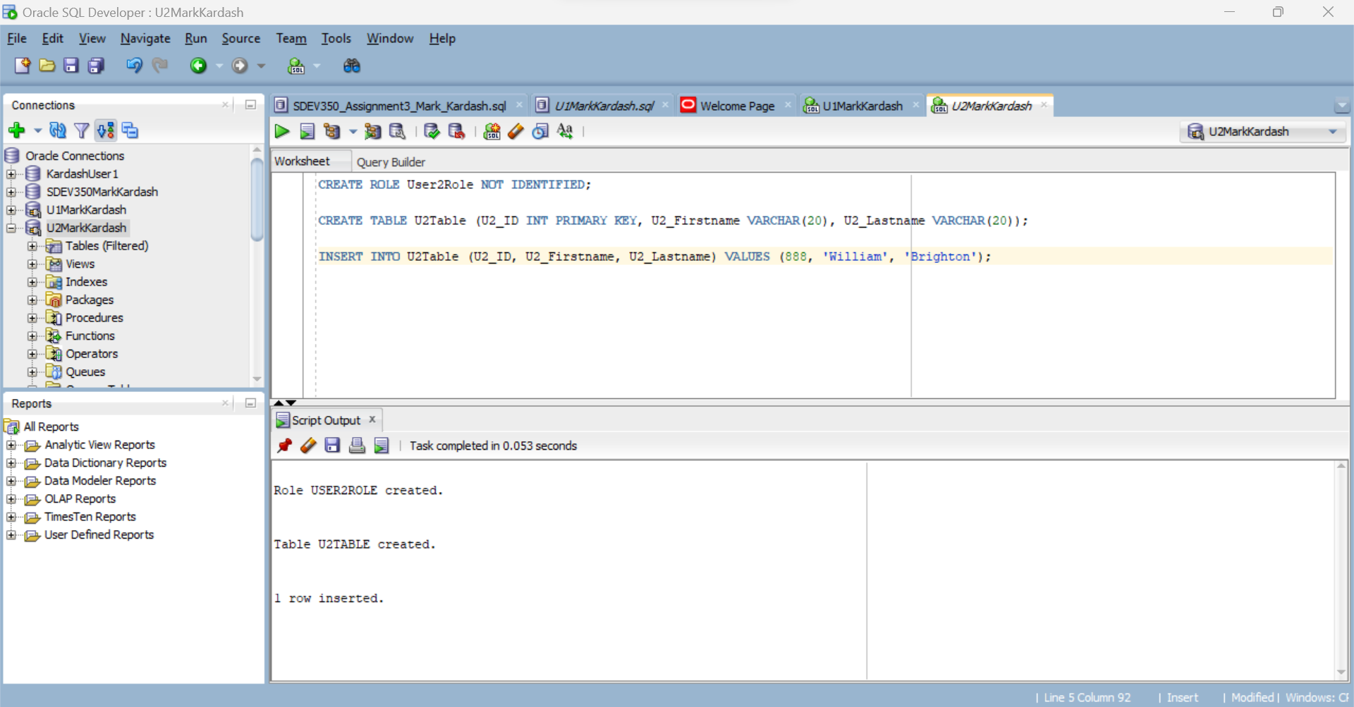

**Figure 39:** Creating a table for U2MarkKardash and inserting a row into it.

Above we demonstrate our success in creating the table User2Table and inserting information into it.

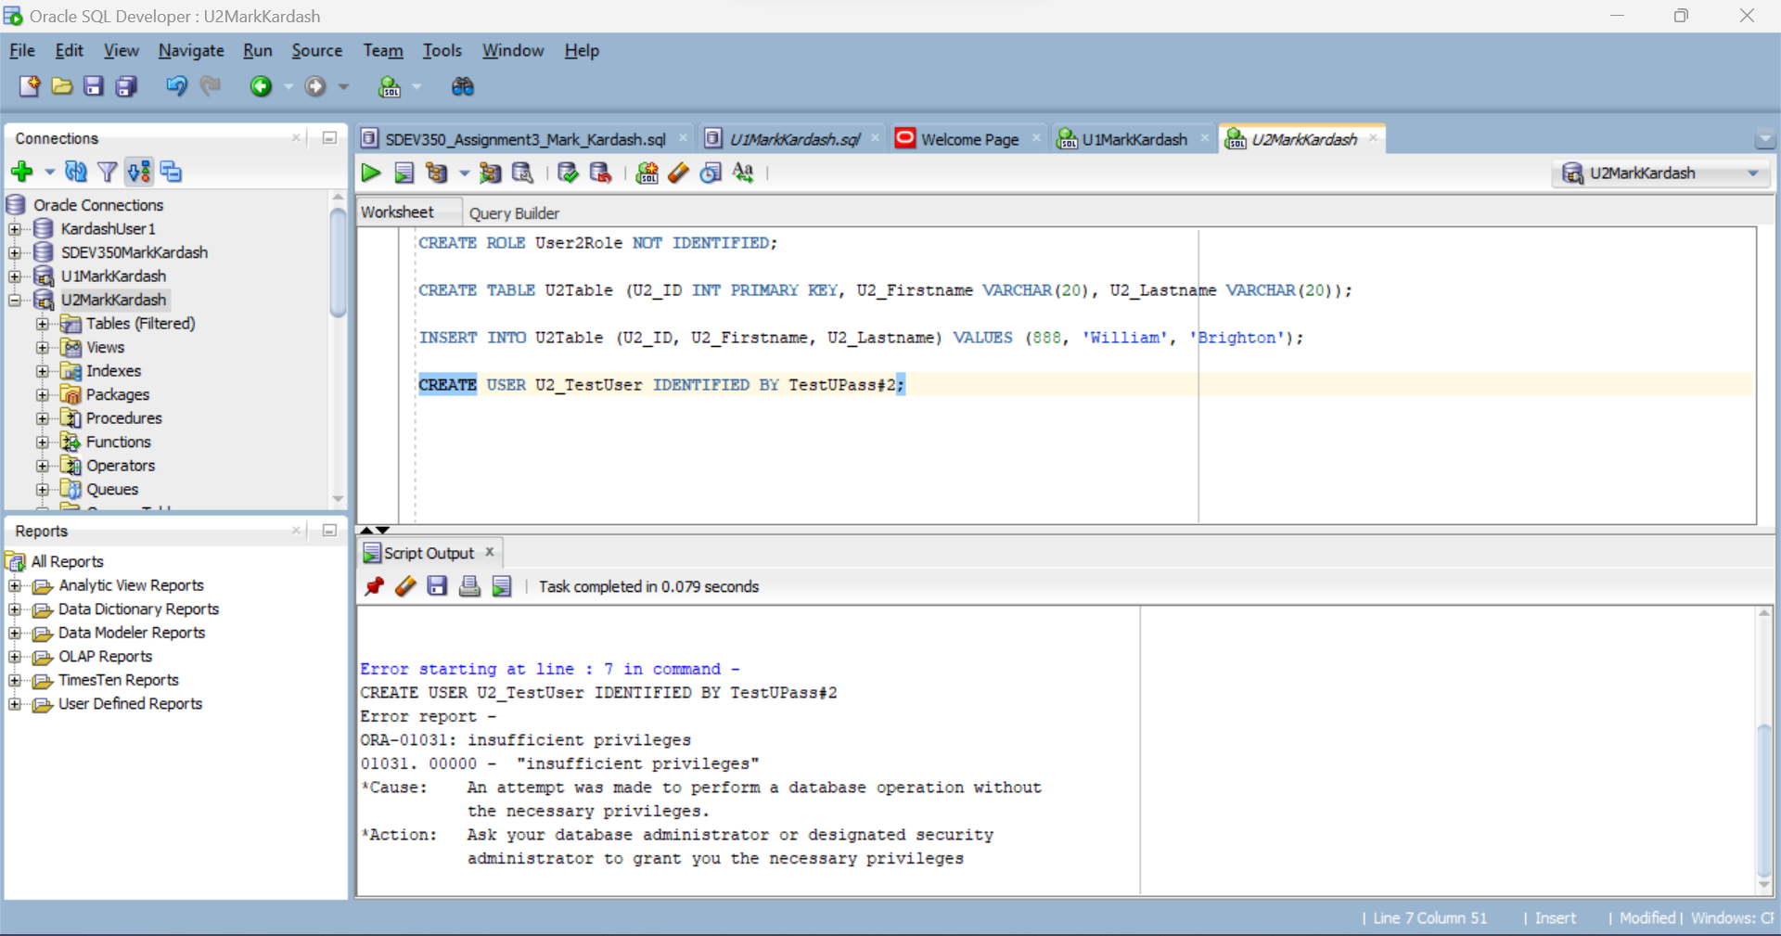

**Figure 40:** Insufficient Privileges Example U2MarkKardash

Once again, we show the limit of privileges the user has by attempting, and expectedly failing, to create a user within the user.

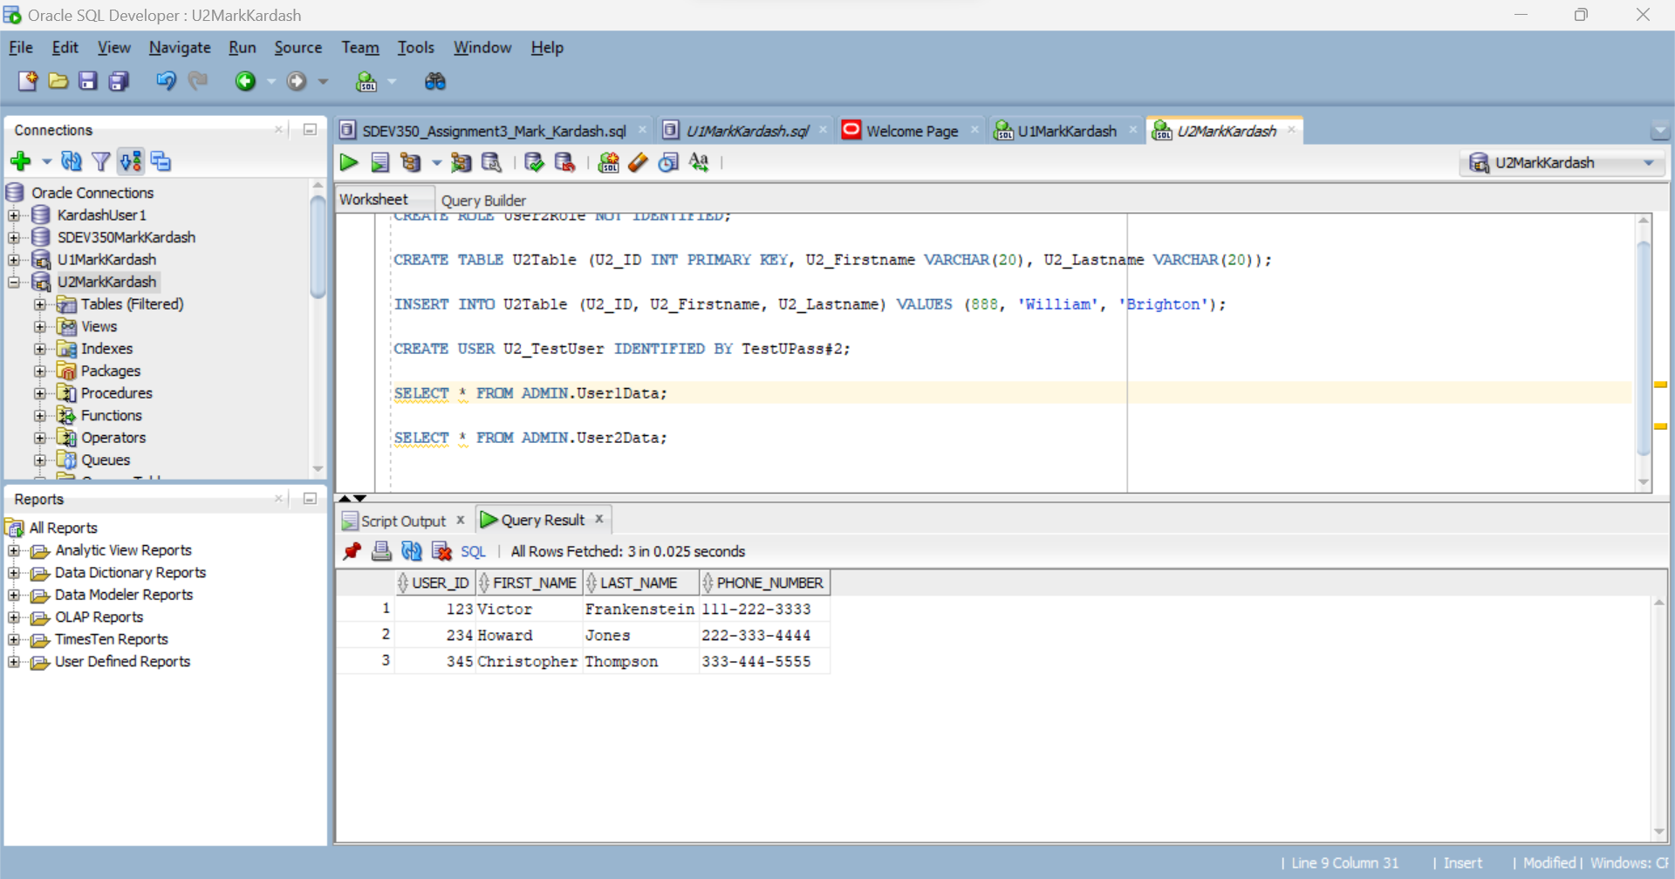

**Figure 41:** Selecting From User1Data (U2MarkKardash)

Per the privileges given to U2MarkKardash, we have successfully selected the User1Data table.

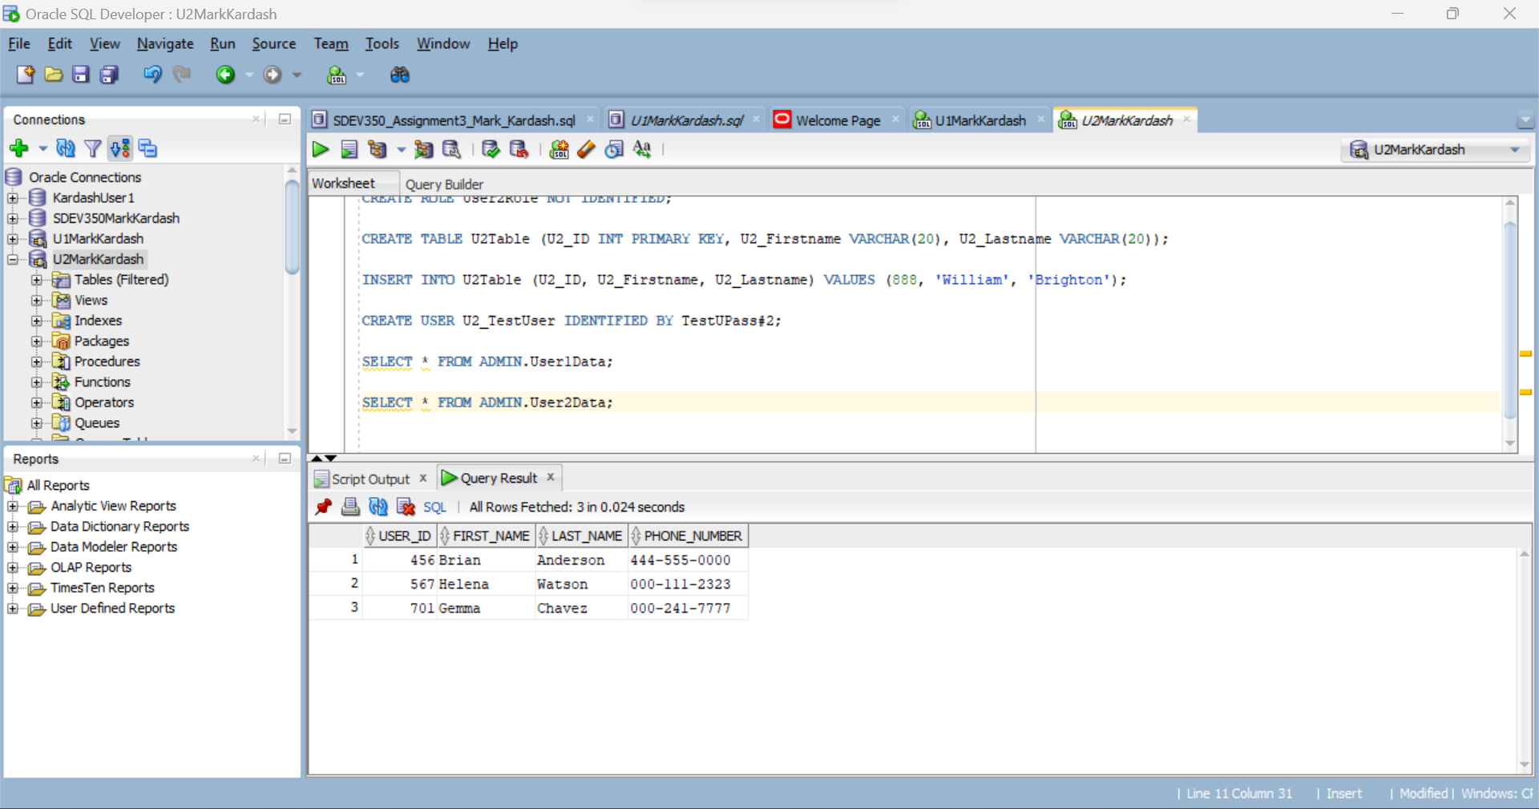

**Figure 42:** Selecting from User2Data (U2MarkKardash)

We now have successfully selected data from User2Data as well, proving the privileges have been granted.

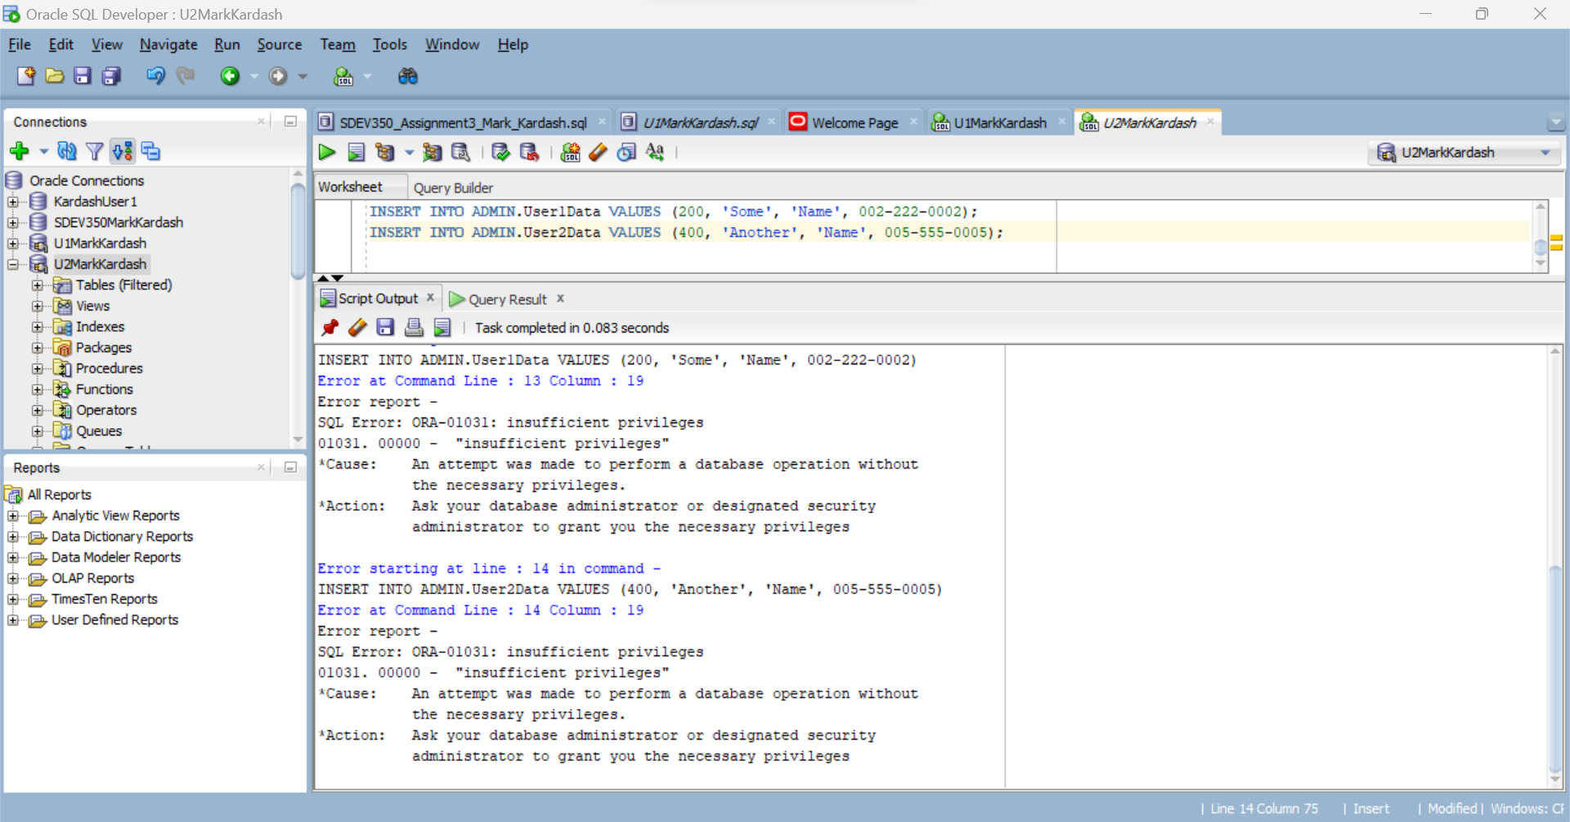

**Figure 43:** Insufficient Privilege Test

As a test, I wrote queries to insert values into both User1Data and User2Data, knowing that, unlike for the first user, such privileges were not given to U2MarkKardash. Expectedly, I received the “Insufficient Privileges” error.

**Conclusion:**

This assignment took me way longer than it should have. Procrastination is mostly to blame for this, but so are the errors that I made. I noticed that my errors were tiny, almost silly, and very much avoidable, had I just paid more attention to them (ex. Entering incorrect hostname, typing an incorrect function, etc.). From this experience, I have learned that I must be more attentive to my work, which is what I resolve to do from now on. And although more extensive testing could perhaps have been done, I think that I have sufficiently tested the code, proving all elements to be working correctly.